**APPLIANCES SWITCHING THROUGH**

**RF-MECHANICAL SWITCH**

**AREA OF RELEVANCE :** electrical and electronics

**TYPE OF PROJECT :** device control

**ABSTRACT :**

The appliances can be controlled manually through switches is an old fashion. Now the way to control it remotely can be bought possible through the radio frequency control or infrared control or wifi or blue tooth is innovated. In my model I had designed a rf model of switching without using relays by using the motors and gears that converts the rotatory movement to linear movement.

**UNIQUE FEATURES :** live operation, high transmission range than ir,wifi,blue tooth.

**Materials used :** a motor, spur gear, linear gear, battery, spokes, m-seal, a card board box, reciver and transmitter circuit and their accessories.

**DELIVERABLE :** cheapest wire less control method.

**EXISTING APPROACH :** to increase the range of operation.

**MY APPROACH :** to reduce the power consumption in the circuits while switching.

**PROPOSAL DIFFERENCE ON ORIGINALITY :** in live time we can apply it to control many devices from a single remote.

**PERFORMANCE :** works both the power supply in on or off state.

**COST FOR BENIFIT :**

**APPROCHES TO SOLVE PROBLEMS :** increasing antenna length for longer transmission.

**MODELING :**

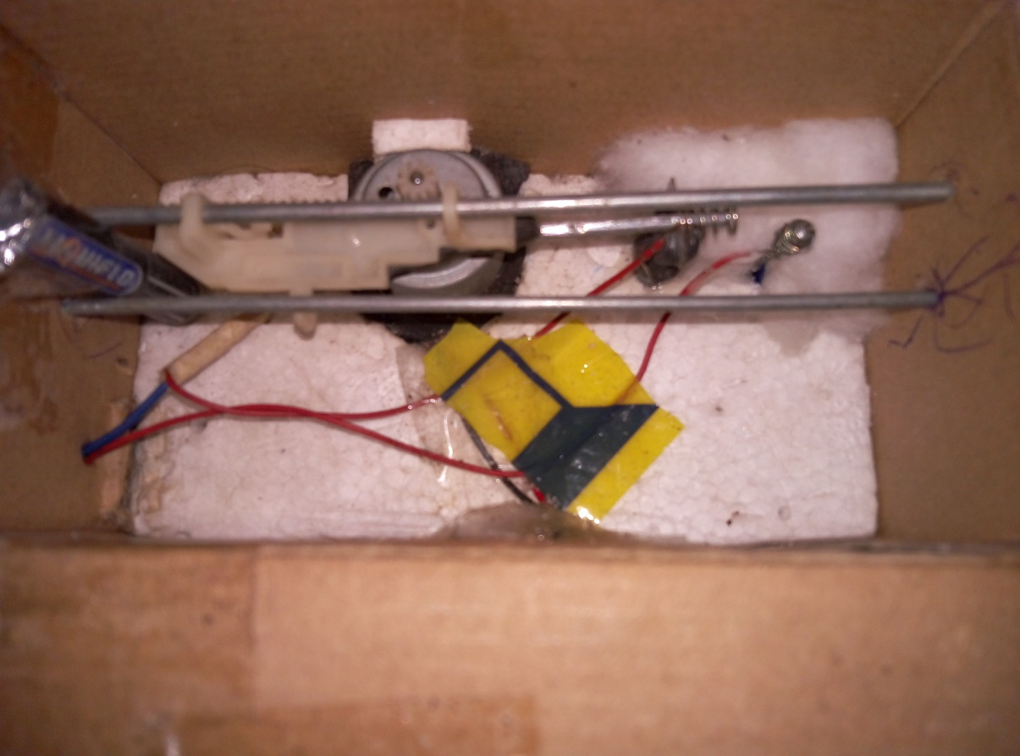

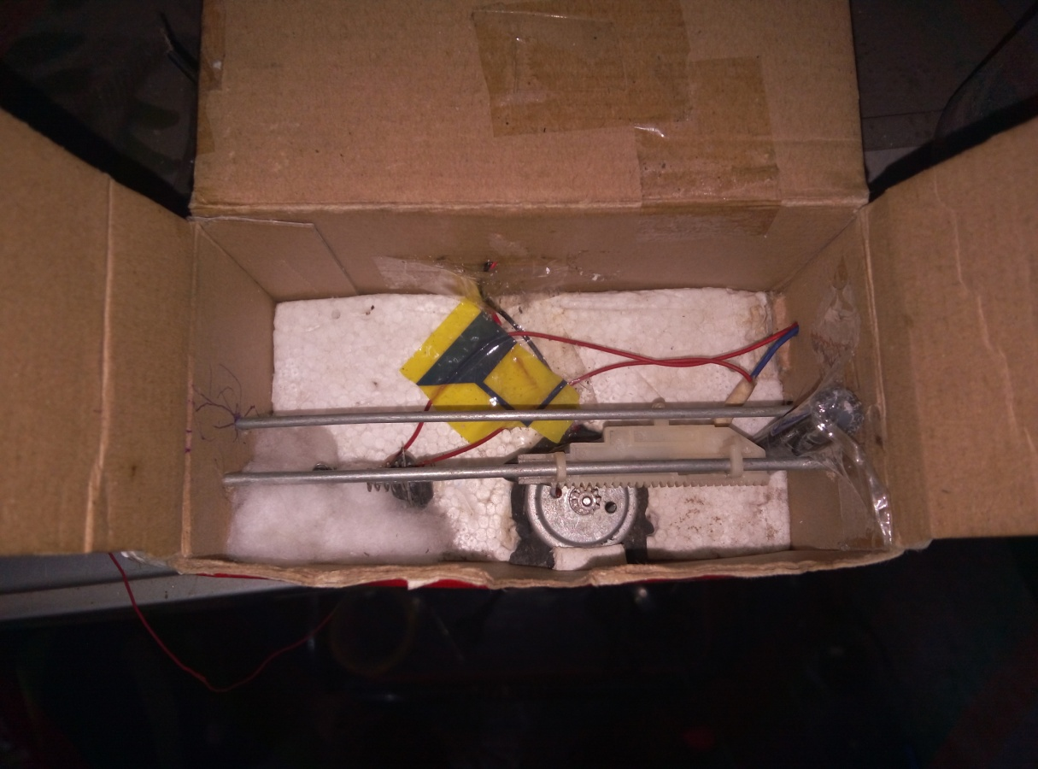

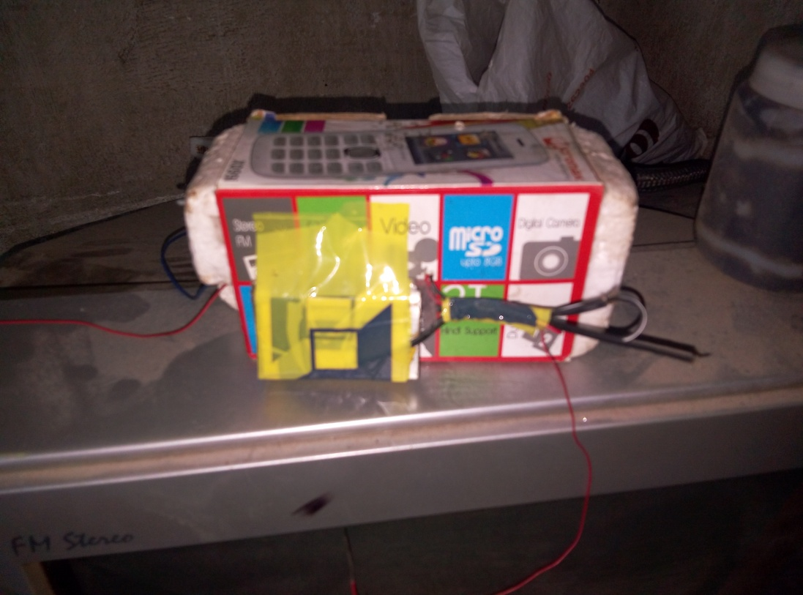

**IMPLEMENT DETAILS :**

A motor drive is connected to the output of the receiver circuit.the motor is connected to a linear gear carrying conductor at the end,that makes the circuit closed and the load acts to consume power and gives respective output work.

**COMPONENTS FOR TESTING :** motor drive testing methods.

**PROGRESS ON TESTING :** the drive controls the conductor at the live time with microseconds delay.

**RESULT :** best way of wireless switching.

**INFRASTRUTURE REQ :** any locality within the range.

**PROBLEMS :** hand held remote is needed.

**DIS ADVANTAGES :** the signal may create noise to other devices.

**RESEARCH** : frequency ranges.

**BUDGET ESTIMATE** : 950 rs for my model.

**CONCLUSION :** high accuracy device.